**1. What is meant by “learning” in the context of machine learning?**

=> “Learning” in the context of machine learning is acquiring skills or knowledge from experience.

Most commonly, this means synthesizing useful concepts from historical data.

**2. What is Machine Learning? Give example.**

=> Machine learning is a branch of artificial intelligence (AI) and computer science

which focuses on the use of data and algorithms

to imitate the way that humans learn, gradually improving its accuracy.

**3. List out the types of machine learning.**

=> Based on the methods and way of learning. Following are types of machine learning :-

1. Supervised Machine Learning
2. Unsupervised Machine Learning
3. Semi-Supervised Machine Learning
4. Reinforcement Learning

**4. What are the differences between supervised and unsupervised learning?**

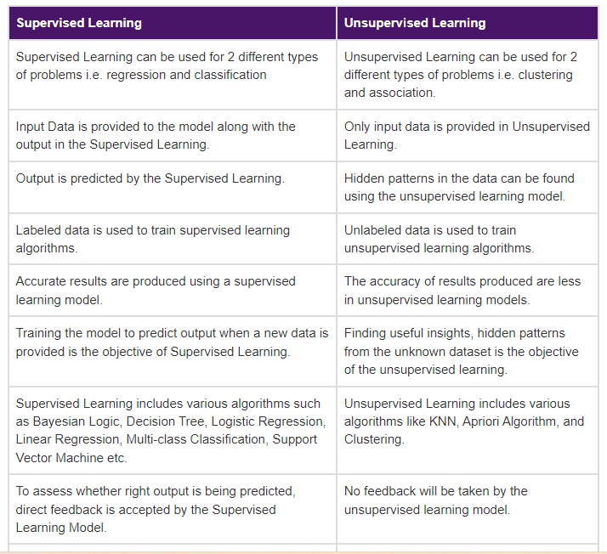

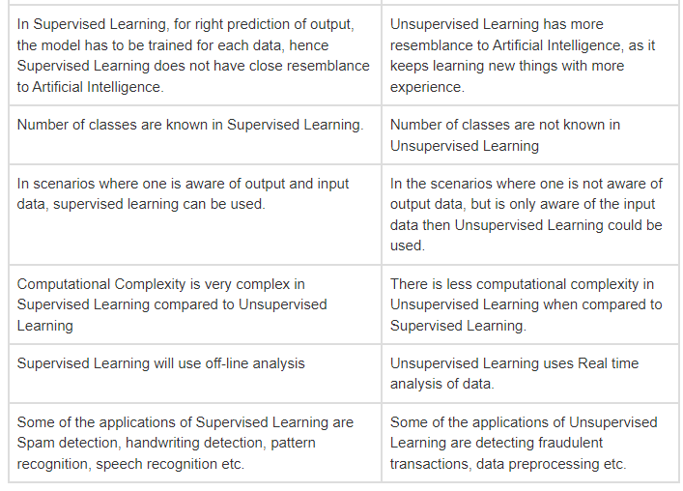

**5. What is meant by supervised classification?**

Supervised classification involves theuseof training area data that are considered representative of each rock type or surficial unit to be classified.

**6. Explain supervised learning with an example.**

Supervised learning is a type of machine learning where well-labelled training data is used to train the machines. Machines use this data to make predictions and give the output. The "labelled" data implies some data is tagged with the right output. The training data that is sent as inputs to the machines work as a supervisor, and it teaches the machine to yield the correct output.

This concept is like students learning under the supervision of a teacher.

Example:

We may use supervised learning to predict house prices. Data having details about the size of the house, price, the number of rooms in the house, garden and other features are needed. We need data about various parameters of the house for thousands of houses and it is then used to train the data. This trained supervised machine learning model can now be used to predict the price of a house.

**7. What do you mean by reinforcement learning?**

Reinforcement machine learning is a machine learning model that is similar to supervised learning, but the algorithm isn’t trained using sample data. This model learns as it goes by using trial and error. A sequence of successful outcomes will be reinforced to develop the best recommendation or policy for a given problem.